**BAR CHART, PIE CHART, LINE CHART IN SSRS**

* Create a report.
* Add the data source and data set.
* Add table and add groups.
* Right click on the table — Click Insert — Click Chart.
* Choose the Charts.
* After the insertion of chart, right click on the chart — Click Show Data Labels.

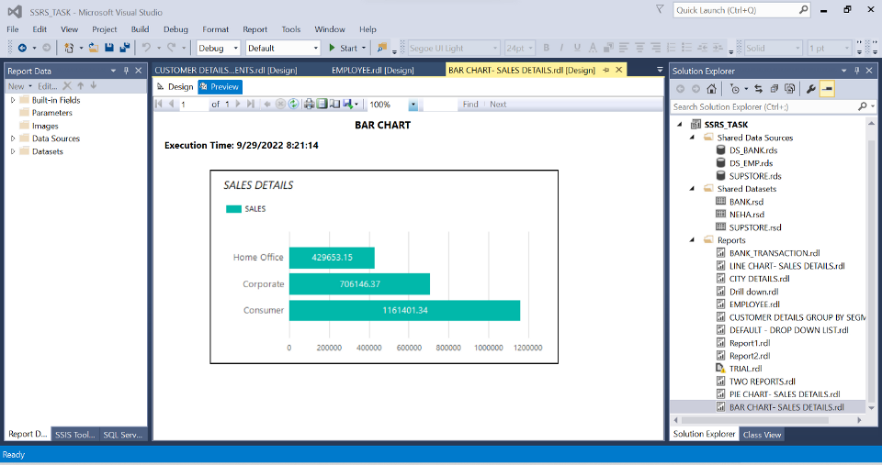

BAR CHART

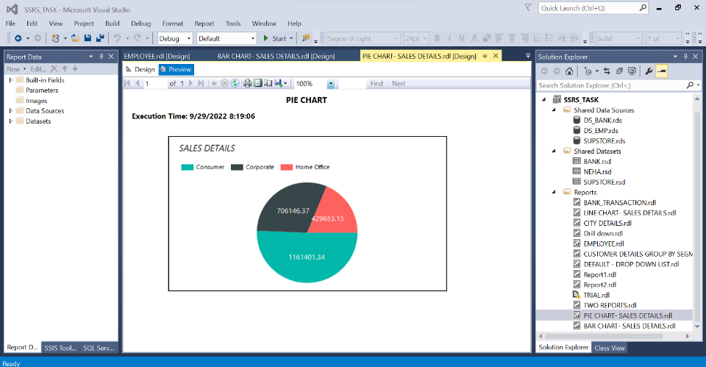

PIE CHART

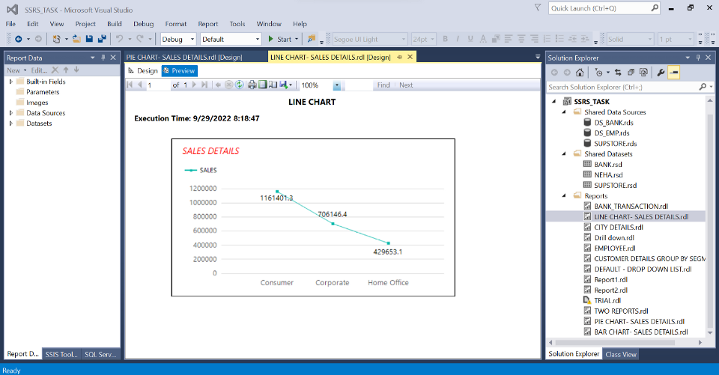

LINE CHART

**Assignment**

**Extract, Transform, Load and generate report using Banking dataset**

* Transform Bank Transaction Details which is in CSV format to SQL Table in SSIS.
* Create a Report in the SSRS.

